Apply Inferential Statistics to Capstone Project 1

Alissa Mezzacappa

For drug use in the last month, there appears to be a strong positive correlation between cannabis and sensation seeking as seen in the figure below. Is the correlation of Cannabis to Sensation Seeking significant?

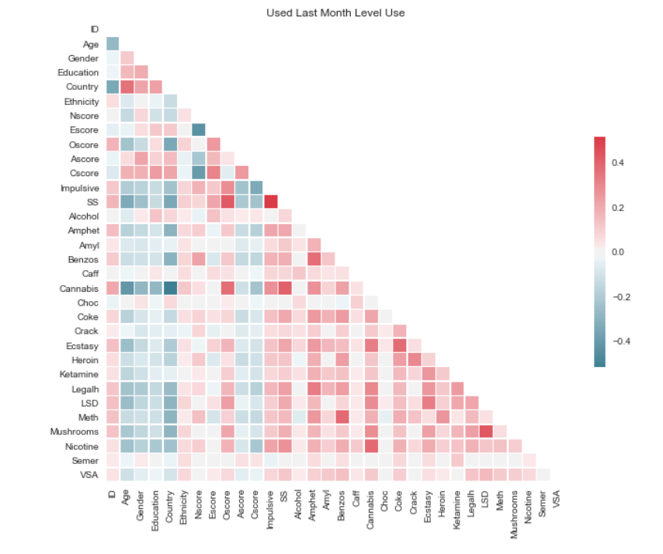

Null Hypothesis: There is no correlation between cannabis use and the SS attribute

Alternative Hypothesis: There is a correlation between cannabis use and the SS attribute

import scipy.stats as st

st.pearsonr(data3.Cannabis,data3.SS)

=(0.40234430777852748, 2.8249216504233784e-74)

P<0.05 therefor it is unlikely this correlation is due to chance and we can reject the null

hypothesis.